**Practical –A-**

**Aim :-**Demonstrate the use of calendar control to do following operations.

**Aim** :- **1)**Display the message in calendar control.

**Source code(Webform1.aspx**) :-

<%@ Page Language="C#" AutoEventWireup="true" CodeBehind="WebForm1.aspx.cs" Inherits="WebApplication5.WebForm1" %>

<!DOCTYPE html>

<html xmlns="http://www.w3.org/1999/xhtml">

<head runat="server">

<title></title>

</head>

<body>

<form id="form1" runat="server">

<div>

<asp:Calendar ID="Calendar1" runat="server" BackColor="#FFFF99" BorderColor="#CC0000" BorderStyle="Solid" FirstDayOfWeek="Monday" ForeColor="Red" Height="233px" OnSelectionChanged="Calendar1_SelectionChanged" SelectedDate="2022-08-05" ShowGridLines="True" Width="395px" OnDayRender="Calendar1_DayRender"></asp:Calendar>

<br />

<br />

<br />

<br />

</div>

</form>

</body>

</html>

**Code Behind (Webform1.aspx.cs) :-**

using System;

using System.Collections.Generic;

using System.Linq;

using System.Web;

using System.Web.UI;

using System.Web.UI.WebControls;

namespace WebApplication5

{

public partial class WebForm1 : System.Web.UI.Page

{

protected void Page_Load(object sender, EventArgs e)

{

}

protected void Calendar1_SelectionChanged(object sender, EventArgs e)

{

}

protected void Calendar1_DayRender(object sender, DayRenderEventArgs e)

{

if (e.Day.Date== new DateTime(2022,8,5))

{

e.Cell.Controls.Add(new LiteralControl("<br/>HOLIDAY"));

}

}

}

}

**Output** :-

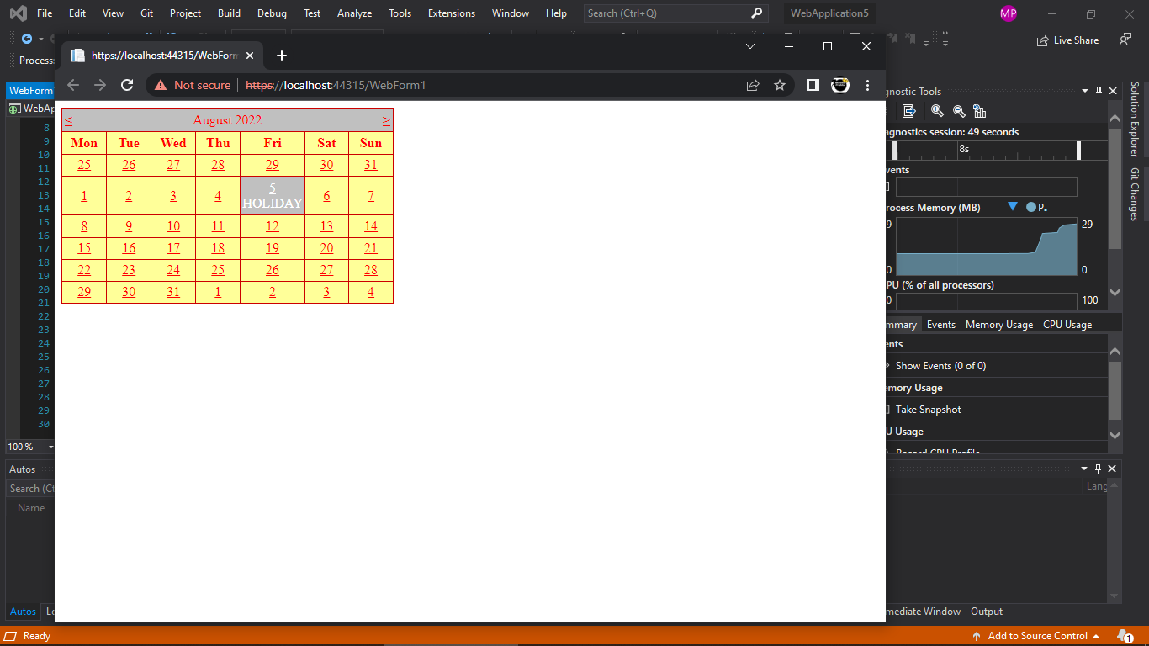

**Aim :-**Demonstrate the use of calendar control to do following operations.

**Aim** :-2)Display vacation in calendar control.

**Source code(Webform1.aspx**) :-

%@ Page Language="C#" AutoEventWireup="true" CodeBehind="WebForm1.aspx.cs" Inherits="WebApplication8.WebForm1" %>

<!DOCTYPE html>

<html xmlns="http://www.w3.org/1999/xhtml">

<head runat="server">

<title></title>

</head>

<body>

<form id="form1" runat="server">

<div>

<br />

<br />

<asp:Calendar ID="Calendar1" runat="server" BackColor="#CCFFCC" BorderColor="#6600FF" BorderStyle="Solid" FirstDayOfWeek="Monday" ForeColor="#FF0066" Height="234px" OnSelectionChanged="Calendar1_SelectionChanged" OndayRender="Calendar1_DayRender" SelectedDate="2022-08-19" ShowGridLines="True" Width="446px"></asp:Calendar>

<br />

<br />

</div>

</form>

</body>

</html>

**Code Behind (Webform1.aspx.cs) :-**

using System;

using System.Collections.Generic;

using System.Linq;

using System.Web;

using System.Web.UI;

using System.Web.UI.WebControls;

namespace WebApplication8

{

public partial class WebForm1 : System.Web.UI.Page

{

protected void Page_Load(object sender, EventArgs e)

{

}

protected void Calendar1_SelectionChanged(object sender, EventArgs e)

{

}

protected void Calendar1_DayRender(object sender, DayRenderEventArgs e)

{

if (e.Day.Date == new DateTime(2022, 8, 19))

{

e.Cell.Controls.Add(new LiteralControl("<br/>DAHIKALA"));

e.Cell.BackColor = System.Drawing.Color.Red;

e.Cell.ForeColor = System.Drawing.Color.Black;

}

}

}

}

**OUTPUT :-**

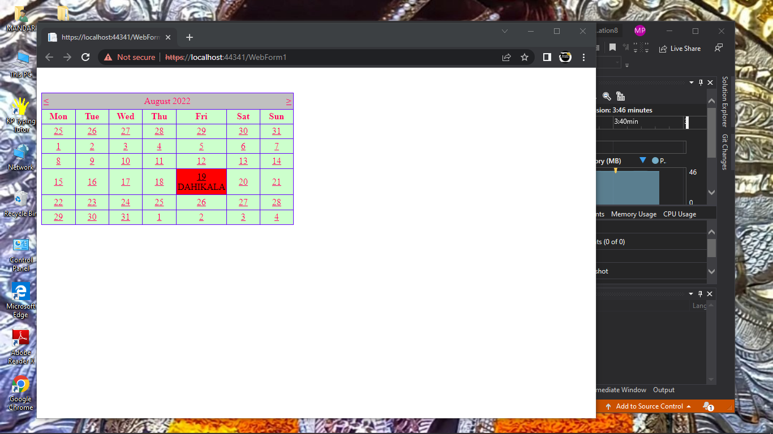

**Aim :-Demonstrate the use of calendar control to do following operations.**

**Aim** :-3) Selected day in a calendar control using style.

**Source code(Webform1.aspx**) :-

<%@ Page Language="C#" AutoEventWireup="true" CodeBehind="WebForm1.aspx.cs" Inherits="WebApplication23.WebForm1" %>

<!DOCTYPE html>

<html xmlns="http://www.w3.org/1999/xhtml">

<head runat="server">

<title></title>

</head>

<body>

<form id="form1" runat="server">

<div style="font-family: 'Times New Roman', Times, serif; position: absolute; border-style: solid; background-color: #CCFFFF; top: 86px; left: 40px; width: 790px; height: 808px;">

<asp:Calendar ID="Calendar1" runat="server" BorderColor="#0066FF" BorderStyle="Solid" BorderWidth="4px" FirstDayOfWeek="Sunday" NextPrevFormat="FullMonth" OnSelectionChanged="Calendar1_SelectionChanged" OnDayRender="Calendar1_DayRender" ShowGridLines="True" TitleFormat="Month"></asp:Calendar>

</div> </form>

</body>

</html>

**Code Behind (Webform1.aspx.cs) :-**

using System;

using System.Collections.Generic;

using System.Linq;

using System.Web;

using System.Web.UI;

using System.Web.UI.WebControls;

namespace WebApplication23

{

public partial class WebForm1 : System.Web.UI.Page

{

protected void Calendar1_SelectionChanged(object sender, EventArgs e)

{

}

protected void Calendar1_DayRender(object sender, DayRenderEventArgs e)

{

if (e.Day.Date == new DateTime(2022, 8, 9))

{

e.Cell.Controls.Add(new LiteralControl("<br/> Holiday"));

}

if (e.Day.Date == new DateTime(2022, 8, 19))

{

e.Cell.Controls.Add(new LiteralControl("<br/> DahiKala"));

e.Cell.BackColor = System.Drawing.Color.Red;

e.Cell.ForeColor = System.Drawing.Color.White;

}

if (e.Day.Date >= new DateTime(2022, 8, 31) && e.Day.Date <= new DateTime(2022, 9, 6))

{

e.Cell.BackColor = System.Drawing.Color.Red;

e.Cell.ForeColor = System.Drawing.Color.White;

}

if(e.Day.Date == new DateTime(2022, 8, 31))

{

e.Cell.Controls.Add(new LiteralControl("<br/> Ganesh Chaturthi"));

}

}

}

}

**OUTPUT ;-**

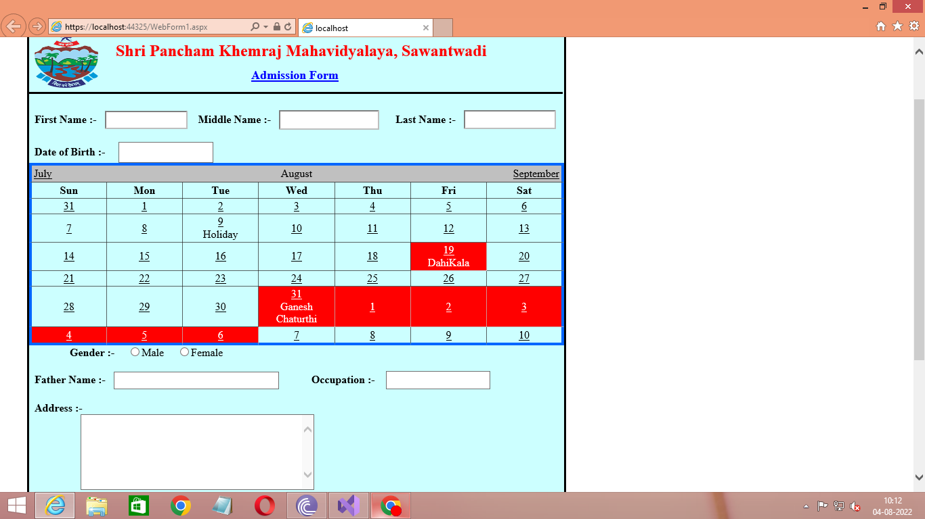

**Aim :-**Demonstrate the use of calendar control to do following operations.

**Aim** :-4) Difference between two calendar dates.

**Source code(Webform1.aspx**) :-

<%@ Page Language="C#" AutoEventWireup="true" CodeBehind="WebForm1.aspx.cs" Inherits="WebApplication9.WebForm1" %>

<!DOCTYPE html>

<html xmlns="http://www.w3.org/1999/xhtml">

<head runat="server">

<title></title>

</head>

<body>

<form id="form1" runat="server">

<div>

<br />

<asp:Calendar ID="Calendar1" runat="server" BackColor="#FFFFCC" BorderColor="#6600FF" BorderStyle="Solid" FirstDayOfWeek="Monday" ForeColor="#FF0066" OnSelectionChanged="Calendar1_SelectionChanged" ShowGridLines="True" Width="361px"></asp:Calendar>

<asp:TextBox ID="TextBox1" runat="server" Width="294px"></asp:TextBox>

<br />

<br />

<asp:Calendar ID="Calendar2" runat="server" BackColor="#FFFFCC" BorderColor="#9900FF" BorderStyle="Solid" ForeColor="#FF0066" OnSelectionChanged="Calendar2_SelectionChanged" ShowGridLines="True" Width="370px"></asp:Calendar>

<br />

<asp:TextBox ID="TextBox2" runat="server" Width="254px"></asp:TextBox>

<br />

<br />

<asp:Button ID="Button1" runat="server" OnClick="Button1_Click" Text="Button" Width="154px" />

<br />

<asp:TextBox ID="TextBox3" runat="server" Width="148px"></asp:TextBox>

<br />

</div>

</form>

</body>

</html>

**Code Behind (Webform1.aspx.cs) :-**

using System;

using System.Collections.Generic;

using System.Linq;

using System.Web;

using System.Web.UI;

using System.Web.UI.WebControls;

namespace WebApplication9

{

public partial class WebForm1 : System.Web.UI.Page

{

protected void Page_Load(object sender, EventArgs e)

{

}

protected void Calendar1_SelectionChanged(object sender, EventArgs e)

{

TextBox1.Text = Calendar1.SelectedDate.ToString();

}

protected void Calendar2_SelectionChanged(object sender, EventArgs e)

{

TextBox2.Text = Calendar2.SelectedDate.ToString();

}

protected void Button1_Click(object sender, EventArgs e)

{

TimeSpan st = Calendar2.SelectedDate - Calendar1.SelectedDate;

TextBox3.Text = st.ToString();

}

}

}

**OUTPUT:-**

